Test Report

Project Name: **eMAG.ro**

Document Date: 13.11.2020

Table of Contents

Testing Scope 3

1.1. Test Environment – [GitHub](https://github.com/luciancalinescu95/Final-Project-eMAG.ro) 3

1.2. Test Specification 4

1.3. Test Cases 4

1.4. Automated Testing 5

1.5. API Testing 6

Test Results 6

2. Executed Test Cases - Functional 6-7

2.1. Executed Test Cases - Non-Functional 7

2.2. Automated Testing 8

2.3. API Testing 9

Bugs and Improvements 9

3. Bugs and Defects 9-10

3.1. Improvements 10

Conclusions 11

# Testing Scope

The testing scope of this project was to test the main functionalities of eMAG.ro from a normal user and tester perspective and find any possible features which were not working correctly and possible improvements for this website.

**Why eMAG.ro?**

It is one the biggest e-commerce chain in Romania with a complex website that features many important functionalities for a shopping website to be tested.

**Testing approach?**

Without knowing or having access to the source code the best approach was smoke black-box testing. We are aware of the main functionalities of the website and what are they supposed to do and we can build the test cases around that.

**What was actually tested?**

Key functionalities for a shopping website like login-logout, creating an account, add to bag, checkout, shopping cart operations, wishlisting products, filtering, search bar.

## Test Environment – [GitHub](https://github.com/luciancalinescu95/Final-Project-eMAG.ro)

Tests were run in the production because we don’t have access to the stage environment. In the github repository you can find the manual Test Cases Plan and Execution Report in TestLink, the UI Tests that were automated with Cypress using JavaScript, the Postman collection of tests for the API Tests and the performance scores of the website that resulted from running Lighthouse.

| Test Environment | Software Details | Comments |
| --- | --- | --- |
| Production | OS:Windows 10 Pro (10.0.19041)  Mobile: Android 9  Devices: Desktop PC, Mobile | Android:eMAG official app; Samsung Internet Browser |
| Browsers:Mozilla Firefox 82.0.3 (64-bit); Google Chrome 86.0.4240.198 (64 bits); Microsoft Edge 86.0.622.56 (64-bit) | DevTools app for Chrome |

1.2. Test Specification

Mind Maps for the website and it’s main functionalities that were tested

* [Website-mindmap](./Mind%20Maps/eMAG.ro%20-%20Site%20Mind%20Map.xmind)
* [Testing-mindmap](./Mind%20Maps/eMAG.ro%20-%20Testing%20Mind%20Map.xmind)

Test Cases Plan → [link](./Test%20Cases%20Plan/Test_Cases_plan_2020-11-10%20.doc)

Test Cases Execution Report → [link](./Test%20Cases%20Plan/Test%20Plan%20Execution%20Report%20-%20eMAG.ro%20-2020-11-13.pdf)

1.3 Test Cases:

|  |  |  |
| --- | --- | --- |
| **Test Case ID(TM-QA08-number)** | **Functionality** | **Comments** |
| 448,449,450,451,452,525 | Login |  |
| 453,454,517,518,519,523,524 | Register Account |  |
| 455,456,457,501 | Favourite Products |  |
| 459,460,461,474,475,520 | Add To Bag |  |
| 462,463,464,465,466,469,470,471,472,  473,541 | Shopping Cart |  |
| 504,503,502,467,468,538,539,542,543 | Account Page(Operations) |  |
| 483,484,485,486,487,488,489,490,491 | Search Bar |  |
| 494,495,496,497,498,499,500,521 | Filter Products |  |
| 533,534,535,536 | - | User Interface |
| 507,508,528,530,531,540 | - | End-to-end |
| 477,476,478,479,480,481,537,505,506,  492,522,526,527,532,529 | - | Non-Functional Tests |

1.4 Automated Testing

For simplifying test execution, increasing the speed of executing manual tests and saving time, the manual tests are automated using the Cypress environment with JavaScript. Note that not all tests can be automated at this point (eg. Login tests require captcha or products changing price or name constantly etc.) and are subject to change. At this point the following tests are automated:

|  |  |  |
| --- | --- | --- |
| **Test Case ID(TM-QA08-number)** | **Functionality** | **Comments** |
| 459,460,461,474,475,520 | Add To Bag |  |
| 462,463,464,469,470,472 | Shopping Cart |  |
| 483,485,486,487,488,489,490,491, | Search Bar |  |
| 494,495,496,497,498,499,521 | Filter Products |  |
| 455,456,457 | Favourite Products |  |

1.5 API Testing

To better understand and check the functionalities, testing techniques, and the execution of test cases, API Testing can be approached. API (Application Programming Interface) enables communications and data exchange between tow separate software systems. Instead of using user inputs and outputs, we can use software to send calls to API, get an output and check the system’s response. API Testing was done using the Postman tool to make requests and check the website’s response on various functionalities.

API test collection → [link](./API%20Test%20Collection/eMAG.ro.postman_collection.json)

API test run results → [link](./API%20Test%20Collection/eMAG.ro.postman_test_run.json)

# Test Results

# 2. Executed Test Cases – Functional

| Functionality | Total | Pass | Failed | Blocked | Not Run | Defects |
| --- | --- | --- | --- | --- | --- | --- |
| Login | 6 | 6 | 0 | 0 | 0 |  |
| Register Account | 7 | 7 | 0 | 0 | 0 |  |
| Favourite Products | 4 | 4 | 0 | 0 | 0 |  |
| Add To Bag | 6 | 6 | 0 | 0 | 0 |  |
| Shopping Cart | 11 | 11 | 0 | 0 | 0 |  |
| Account Page Operations | 9 | 9 | 0 | 0 | 0 |  |
| Search Bar | 9 | 9 | 0 | 0 | 0 |  |
| Filter Products | 7 | 6 | 1 | 0 | 0 | 1 |
| User Interface | 4 | 4 | 0 | 0 | 0 |  |
| End-to-end | 6 | 4 | 2 | 0 | 0 | 2 |
| **Overall Results** | **70** | **67** | **3** | **0** | **0** | **3** |

2.1. Executed Test Cases – Non-Functional

|  |  |  |  |  |  |  |
| --- | --- | --- | --- | --- | --- | --- |
| Description | Total | Pass | Failed | Blocked | Not Run | Defects |
| Performance | 2 | 1 | 1 | 0 | 0 | 1 |
| Compability | 7 | 7 | 0 | 0 | 0 |  |
| Security | 5 | 4 | 1 | 0 | 0 | 1 |
| API | 1 | 1 | 0 | 0 | 0 |  |
| **Overall Results** | **15** | **13** | **2** | **0** | **0** |  |

2.2 Automated Testing

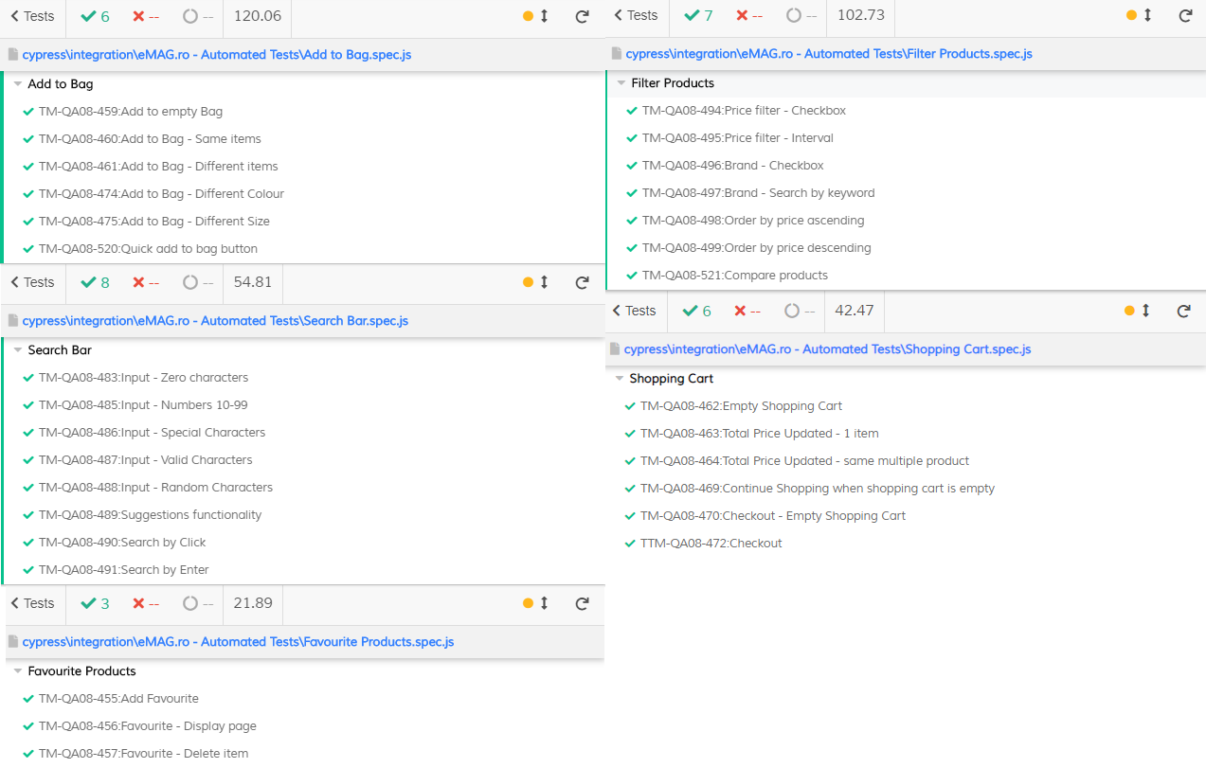

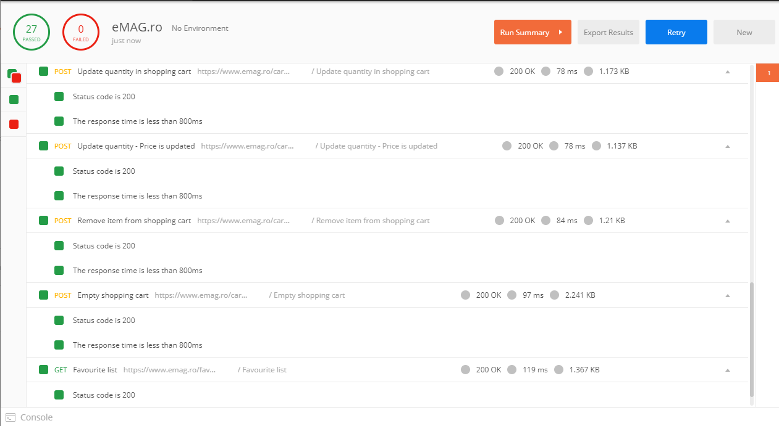2.3 API Testing

# Bugs and Improvements

3. Bugs and Defects

| Defect ID | Defect summary | Severity |
| --- | --- | --- |
| [101](./Bugs%20and%20Defects/BugsAndDefects.xlsx) | Colour filter not working correctly | moderate |
| [102](./Bugs%20and%20Defects/BugsAndDefects.xlsx) | Guests can’t checkout | moderate |
| [103](./Bugs%20and%20Defects/BugsAndDefects.xlsx) | Guests can’t create wishlist | moderate |
| [104](./Bugs%20and%20Defects/BugsAndDefects.xlsx) | Performance scores are not up to metrics | moderate |
| [105](./Bugs%20and%20Defects/BugsAndDefects.xlsx) | No email validation link sent | major |

3.1. Improvements

|  |  |  |
| --- | --- | --- |
| ID | Summary | Importance |
| [201](./Bugs%20and%20Improvements/Improvements.xlsx) | Scroll back-to-top button | moderate |
| [202](./Bugs%20and%20Improvements/Improvements.xlsx) | Register Account - Twitter | minor |
| [203](./Bugs%20and%20Improvements/Improvements.xlsx) | Add English Language | major |
| [204](./Bugs%20and%20Improvements/Improvements.xlsx) | Clothes size guide | major |
| [205](./Bugs%20and%20Improvements/Improvements.xlsx) | Failed sign-in email notification | major |

## 

# Conclusions

Most important functionalities were covered with smoke testing test cases and 100% of them were executed manually with a percentage of 94.1% passed tests and 5.8% test failed.

Almost 30% of manual test cases were automated in Cypress with a percentage of 100% passed.

The failed test cases are related to the colour filter functionality, checkout, performance measure and security.

A number of five bugs were found with four of them identified as moderate and one as major severity.The bugs related to guest functionalities can be turned into improvements or features.

The bug identified with major severity is related to security and it is recommended to be fixed as it can affect potential users.

The bugs are not validated.

In addition to Smoke Testing, types such as: Functional Testing,Non-Functional, UI, Compability, Component, Security, Regression, Negative were covered.

Compatibility testing was also performed, for three different browsers and one Android device. The testing on Android device was done using Samsung Internet Browser and official eMAG app on Google Play. The bugs reproduce on all browsers and devices.

Testing environment comprise of a Desktop PC with Windows 10 with browsers: Chrome,Firefox,Microsoft Edge latest versions and Samsung Android device with Android 9.0 with Samsung Internet Browser.